

**NEURODIVERGENT LEARNING SOLUTIONS**

**AI Assisted**

**Learning**

Innovative solutions for

personalized education



Agenda

|  |  |  |
| --- | --- | --- |
| **Problem** | **Solution** | **Tech Stack** |

|  |  |  |
| --- | --- | --- |
| Understanding needs | AI integration | Tools |

|  |  |  |
| --- | --- | --- |
| Identifying challenges | Personalized learning | Frameworks used |

|  |  |  |
| --- | --- | --- |
| Inclusive design | User feedback | Development languages |

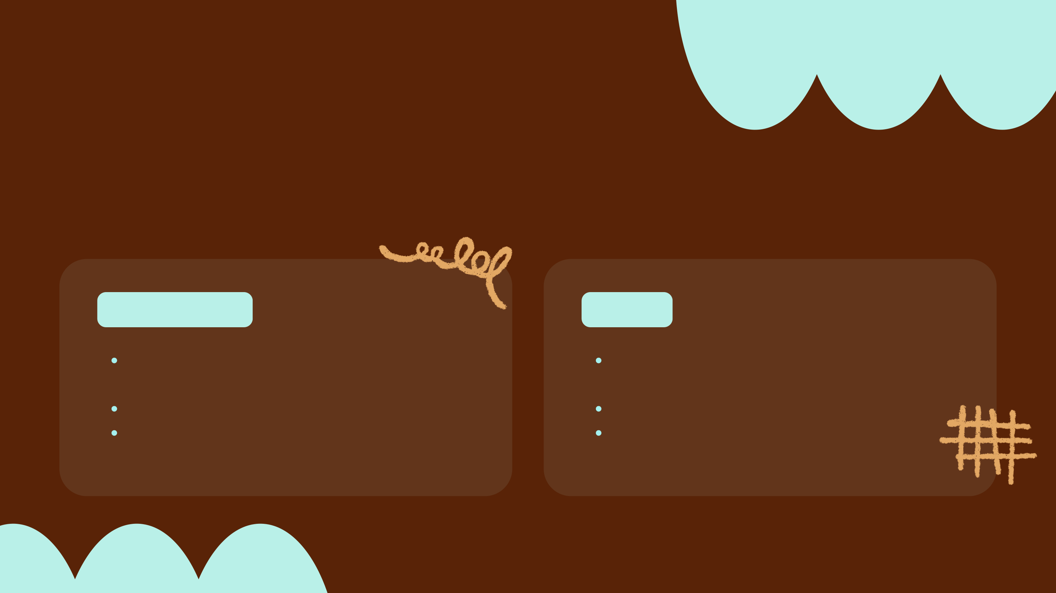

Overview

Neurodivergent students often face significant **barriers** in traditional

classrooms, which can hinder their learning experiences and overall success.

**OBJECTIVES**  **GOALS**

Enhance learning Improve academic

engagement performance

Provide tailored content Increase student retention

Foster inclusive Support individual needs

environments



Project Scope

|  |  |  |  |
| --- | --- | --- | --- |
| **Personalized** | AI integration for | Accessible **learning** | Data-driven |

|  |  |  |  |
| --- | --- | --- | --- |
| **learning** experiences | **neurodiversity** | **tools** | **progress tracking** |

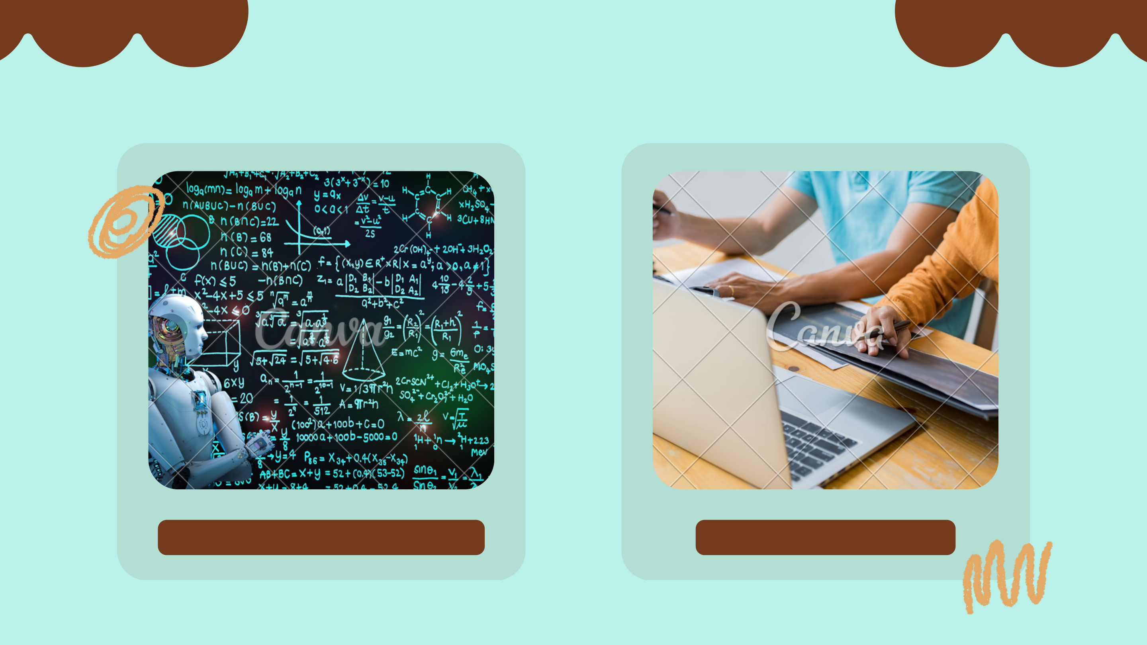

**Tech Stack**

**INNOVATIVE TECHNOLOGIES**  **DEVELOPMENT TOOLS**

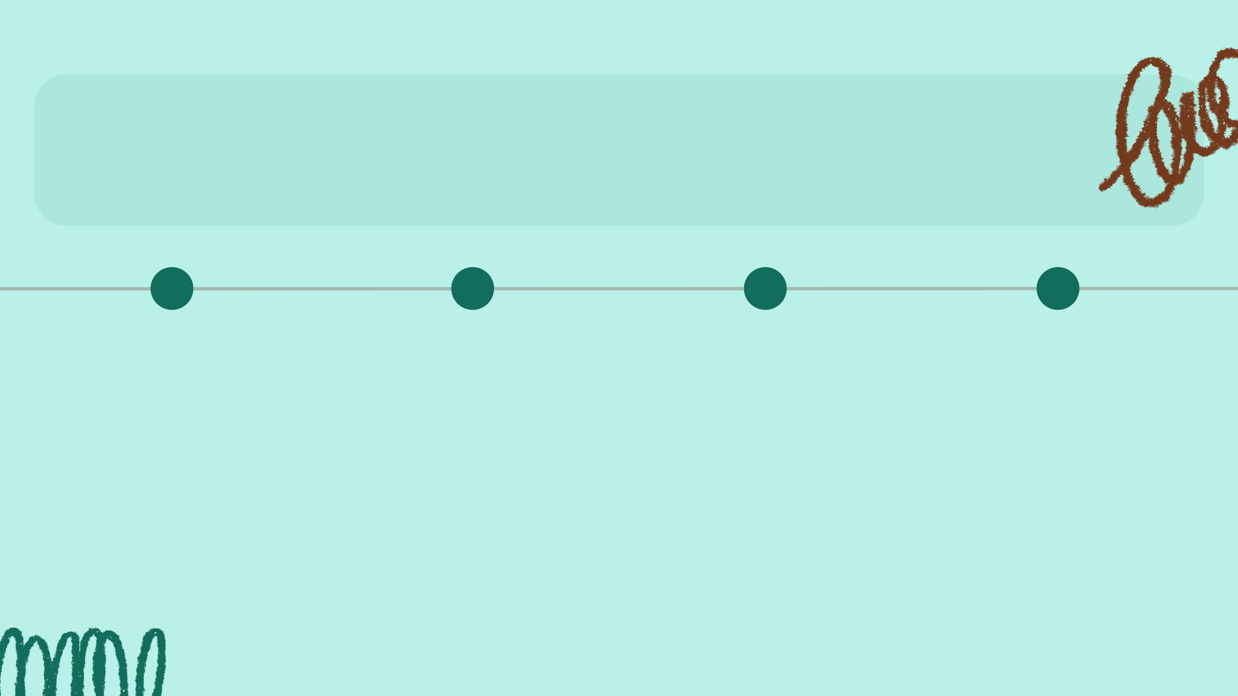

Innovation Tips

|  |  |  |  |
| --- | --- | --- | --- |
| **USER-CENTRIC** | **DATA-DRIVEN** | **COLLABORATIVE** | **ITERATIVE** |
| **DESIGN** | **INSIGHTS** | **TOOLS** | **DEVELOPMENT** |

|  |  |  |  |
| --- | --- | --- | --- |
| Focus on **individual** | Utilize analytics to | Incorporate | Regular updates |

|  |  |  |  |
| --- | --- | --- | --- |
| **needs** for | **adapt learning** | **community** | ensure **adaptive** |

|  |  |  |  |
| --- | --- | --- | --- |
| personalized learning | **paths** effectively. | **feedback** for | **learning** remains |

|  |  |  |
| --- | --- | --- |
| experiences. | continuous | effective. |

improvement.



Future Scalability Potential

This diagram illustrates our **expansion strategies** for broader impact.

|  |  |  |
| --- | --- | --- |
| Inclusive design for all | Customizable learning | Leveraging technology for |
| experiences for diverse | effective learning |
| neurodivergent students |
| needs | solutions |

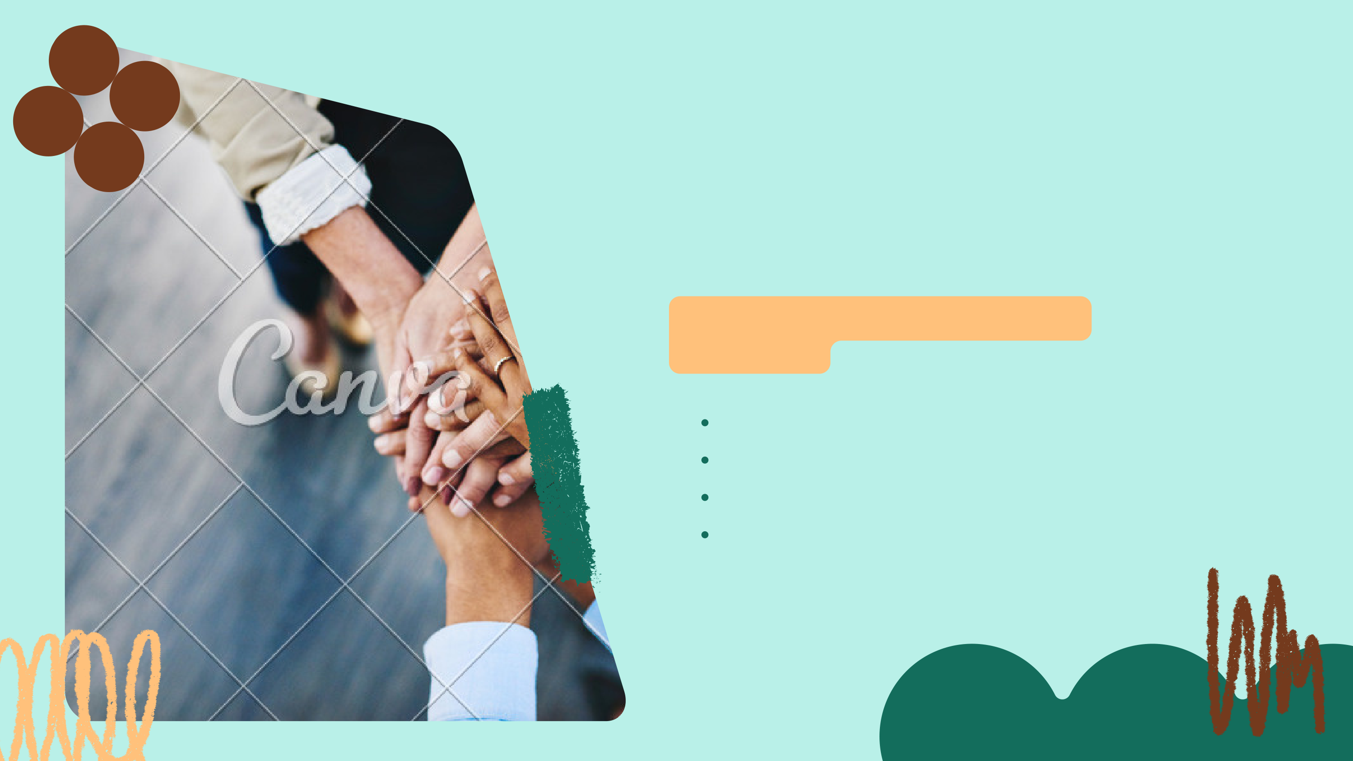

**Meet Our**   
**Innovative Team**

**HERE'S OUR TALENTED TEAM**   
**MEMBERS**

Divyanshi: Leader & Backend Developer   
Dhriti Dixit: Frontend Developer   
Kashish Bhandari: Tester   
Priyanshi Singh: API & Framework



Thank you! Questions?